**CPSC 8750 ASSIGNMENT**

**ATAM EVALUATION OF SMART HOME ARCHITECTURE**

Architecture Design: - Aditya Patil and Amey Patil

***PHASE 0*** (Partnership and Preparation)

Meeting Dates: - 4/4/2016

Who Must Attend: - Manager, Developer, Architect and ATAM Evaluators.

Agenda: -To perform ATAM evaluation of the Smart Home Architecture developed by a team as a CPSC 875 project work.

***PHASE 1***

**STEP 1: - Present the ATAM**

Following steps are followed to present the ATAM analysis of Smart Home Architecture.

**STEP 2: - Present Business Drivers**

Business drivers are extracted using the “Smart Home Architecture Document” which contains detailed design and architectural designs made by the team to develop the overall architecture. This SAD is treated as major reference document for the overall ATAM Evaluation process.

The following business drivers are most crucial: -

|  |  |  |  |  |
| --- | --- | --- | --- | --- |
| **BUSINESS DRIVER** | **BUSINESS CONSTRAINTS** | **BUSINESS**  **GOALS** | **STAKEHOLDER** | **ARCHITECTURAL DRIVERS** |
| Excellent User Experience while using the Smart Home System. | Cost of Hardware.  Service and Maintenance | Business Requirement  Usability  Excellent GUI | User | Safety of the User  Reliability |
| Efficient Management of attached appliances. | Energy Saving Criteria.  Latency | Cost Reduction  Long lasting System. | System Architect | Latency  Maintainability |
| Error Detection and mitigation | Latency  Error Notification/detection system. | Safety of customer  Error tolerance | System  Architect | Safety  Usability |
| Appliances automation and Notification | Hardware involved  GUI in use. | Appliances should be capable of automation.  Appliances should have the ability to notify any spurious activity | Developer | Efficiency  Correctness  Error-Tolerance |
| Easy to use, modify and update | Software platform in use | System should be easy to understand by a layman. | Executive  Architect | Resource Economy  Usability |

**STEP 3: - Present Architecture**

The Smart Home System Architecture is based on pipeline architecture. The system is modeled and implemented for sunny day and rainy day scenarios using AADL language. STEP4 will discuss in detail about the architectural approaches followed by the architects while implementing the system. The underlining architectural type is taken from the reference SAD.

**STEP 4: - Present Architectural Approaches**

Present architectural approaches are evaluated based on the inputs from the “Smart Home System Architecture Document” provided by the architect team.

The following architectures are listed in the SAD based on the various views

1. Between Central controller and Components (Appliances)

Pipeline Architecture: - The components communicate with each other in a pipeline manner because the output of one component is an input to another component. The Smart Home system is decomposed according to various functional and non-functional requirements of the system.

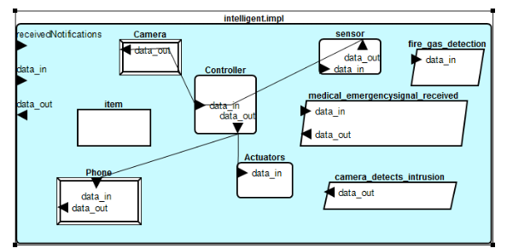

1. Between User and System

MVC Architecture: - User communicates with the components via using a GUI. The controller loads a particular view in the GUI based on the chosen component. Some views such as Set Parameters, Get Distribution Statistics are loaded independently of any particular component based on the user.

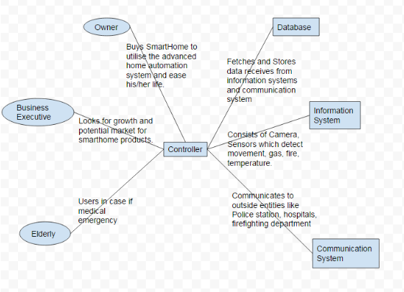

**STEP 5: - Generate QA Utility tree based on QAW**

This QAW is performed by the ATAM Evaluation team based on the Smart Home System Architectural Document and other factors. After considering many factors such as Architect input, other team member inputs, engineering judgement, feasibility of design etc. the scenarios are created for Smart Parking System. Some of the important scenarios are listed below.

QAW Use case scenarios:

Use Case 1

Scenario(s): User should be able to use the system safely.

Business Goals: Provide safety requirements for Smart Parking System

Relevant Quality Attributes: Safety, Reliability

Stimulus: Safety of the user is the prime responsibility.

Stimulus source: Automation of appliances requires continuous monitoring for safety goal violations.

Environment: Normal, Extreme test environment.

Artifact (If known): Safety guidelines set by the underlying committee.

Response: System should notify and shut down in case of safety goal violation like leakage, theft, false alarms, false negative etc.

Response Measure: Safety of the Owner, Electronic appliances ability to work in a safe zone.

Use Case 2

Scenario(s): Appliances should be able to perform in an automatic mode without much user support.

Business Goals: Energy Saving, Efficiency, Appliance maintenance

Relevant Quality Attributes: Latency, Reliability, correctness

Stimulus: Smart home appliances should make smart decisions.

Stimulus source: It is necessary for making efficient and reliable smart home.

Environment: Normal, Extreme test environment.

Artifact (If known): Specifications providing appliance behaviors in every conditions.

Response: A smart home where the components are able to make decisions based on controller inputs.

Response Measure: Appliances behavior test, Controller latency.

Use Case 3

Scenario(s): System should be easy to use.

Business Goals: Increase usability especially for no-technical users.

Relevant Quality Attributes: Reliability, Efficiency

Stimulus: Smart home system would be used by various types of users.

Stimulus source: An easy to use system will have higher impact on users.

Environment: Normal daily home environment.

Artifact (If known): GUI specifications, Instruction Manual.

Response: System would be used in a universal manner.

Response Measure: Instruction manual test, service or inquiry calls after installing the system.

Use Case 4

Scenario(s): System should be easy to manage, update and install.

Business Goals: It enhances portability and maintainability.

Relevant Quality Attributes: Maintainability, efficiency

Stimulus: Smart home system would be updated frequently for new hardware (Appliances) installations, software update and maintenance.

Stimulus source: Updating a system which gets bigger and bigger requires time, resource and money.

Environment: Software update, Hardware update (both controller and appliances).

Artifact (If known): Instruction Manual.

Response: Easy to manage system will make more sell and minimum service effort.

Response Measure: Update timing, Controller latency, power consumption and lifetime.

Use Case 5

Scenario(s): System should be secure.

Business Goals: Authentication and identification prior to use and data privacy.

Relevant Quality Attributes: Reliability and Security

Stimulus: System should provide at least basic security measures.

Stimulus source: The system could prove to be fatal in the hands of hackers or malicious users.

Environment: Extreme test environment.

Artifact (If known): Security norms used by industry.

Response: A secure system will protect the user from many problems like privacy violations, identity theft etc.

Response Measure: Security Mechanisms, Security Review, Ethical Hacking.

Based on the following QAW scenarios, a Quality Attribute Utility tree is built. This utility tree is not based on the prioritized scenarios. Prioritization will be done in subsequent sections of the ATAM evaluation.

|  |  |  |  |  |
| --- | --- | --- | --- | --- |
| QA Level1 | QA Level2 | (BP) | (TP) | Scenario |
| Safety | Normal Mode | H | H | Stop the system if normal execution mode reaches to its limit, such as extreme temperature, and notify the user |
| Error Mode | H | H | Stop the system in case of error or false negative and notify user |
| latency | Normal mode / error mode | M | M | System should be fast in responding a user request. |
| Update or maintenance mode | M | M | System should not be extremely slow in responding a user request. |
| Reliability | Normal Case | H | M | System should work as per specifications |
| Emergency case | H | M | System should work as per specifications |
| Correctness | Normal Mode | H | M | System should display correct information at all time, perform self-checks on sensors and other sub-systems |
| Error Mode | H | H | System should display error message and should not be turned on without checking the handling of error. |
| Maintainability | maintenance | M | M | Easy to maintain |
| Ease of use | Normal Mode | H | M | User friendly system |
| Failure Mode | H | M | System should prompt an error message and exit. |
| Security | Nominal | H | M | System should always check for all security concerns and should shut down with notification in case of security concern. |
| Advanced | H | H | System should always check for all security concerns and should shut down with notification in case of security concern. |

**STEP 6: - Analyze Architectural Approaches**

The Smart Home System Architecture is mainly based on Pipeline Architectural Approach. The Architects have used various views to analyze the approach selected by them. The views are documented in the SAD.

The ATAM evaluation team will perform detailed analysis of architectural approach and provide the result in the STEP8 of the ATAM Evaluation.

***PHASE 2***

**STEP 7:- Brainstorm and prioritize scenarios**

The scenarios are prioritized using the Quality attribute Workshop and Quality attribute utility tree described in the earlier sections.

The prioritized scenarios based on quality attribute workshop are given as follows: -

|  |  |  |  |  |
| --- | --- | --- | --- | --- |
| QA Level1 | QA Level2 | (BP) | (TP) | Scenario |
| Safety | Normal Mode | H | H | Stop the system if normal execution mode reaches to its limit, such as extreme temperature, and notify the user |
| Error Mode | H | H | Stop the system in case of error or false negative and notify user |
| Correctness | Normal Mode | H | M | System should display correct information at all time, perform self-checks on sensors and other sub-systems |
| Error Mode | H | H | System should display error message and should not be turned on without checking the handling of error. |
| Reliability | Normal Case | H | M | System should work as per specifications |
| Emergency case | H | M | System should work as per specifications |
| Security | Nominal | H | M | System should always check for all security concerns and should shut down with notification in case of security concern. |
| Advanced | H | H | System should always check for all security concerns and should shut down with notification in case of security concern. |
| Ease of use / Efficiency | Normal Mode | H | M | User friendly system |
| Failure Mode | H | M | System should prompt an error message and exit. |

**STEP 8:- Detail Architectural approach analysis**

The Smart Home System SAD provides two major architectural approaches to implement. The ATAM evaluation of the architecture described in the SAD evaluated these approaches based on various architectural and business factors and found following results. These results are documented in form of Trade-offs, risk, Non-risk and Sensitivity points as follows:-

**Architectural Approach**: - Pipeline Architecture (Between Controller and Components)

**Sensitivity Points: -** Multiple Component failures, dependencies between components (for example: - Heater and Cooler both on!), Indirect environmental effects

**Trade-Off: -**

1. Latency will increase due to the centralization of the controller.
2. Security of the system will be compromised while making the system more user-friendly.
3. System should not be reliable and efficient while providing minimum latency.

**Risk: -**

1. Security will not be efficient in case of pipeline architecture.
2. Components will follow a linear path to provide information to the controller which will reduce the efficiency and reliability of the system.
3. Updating the system to cater the future need of the users will be difficult.

**Non-Risk: -**

1. Safety of the system would be high, if pipeline architectural is implemented as each information could be validated at several layers.
2. System will work efficiently in normal case scenario.

**Architectural Approach**: - MVC Architecture (Between Controller and User)

**Sensitivity Points: -** Multiple views at the same time, different conflicting views, latency

**Trade-Off: -**

1. Security will be compromised in order to provide efficiency, user friendly GUI.
2. At most one view could be registered at one time. It hampers parallel processing of the components.

**Risk: -**

1. Multiple views are not handled simultaneously.
2. Safety of the system depends on the notification system through GUI.

**Non-Risk: -**

1. Normal behavior will be provided in an efficient manner.

**STEP 9:- Present Result**

Based on the ATAM evaluation of the architecture, ATAM evaluation team has documented some results which should be implemented in the architecture with high priority.

Architecture: -

Instead of fixed pipeline architecture, the system could be built by using a hybrid architecture consisting of Client-Server Model (between controller and components) and Bus Architecture (between the components) to ensure more safety and security. MVC architecture used for user communication is ok.

System: -

Currently, the system uses a powerful centralized controller to provide minimum latency. However two different controllers could be used for user-controller communication and controller-component communication. It will increase the latency as it will put some load off a single controller. It will also increase safety and security of the system.

Requirements: -

More requirements addressing security of the system as a whole should be added to the system.

***PHASE 3***

**STEP 10: - Follow UP**

The ATAM analysis is shared with the architect team and results of the ATAM are discussed with the team.